**Course 2 Capstone Peer Review 1 Tutorial**

This tutorial walks you through most of the steps involved in updating the starter code base to implement the Command pattern. The steps in this tutorial are:

1. Clear the app memory
2. Create and implement the abstract Command class
3. Create and implement the AddItemCommand class
4. Update the ItemList class
5. Create and implement the DeleteItemCommand class
6. Create and implement the EditItemCommand class
7. Update AddItemActivity to use AddItemCommand
8. Update EditItemActivity to use DeleteItemCommand and EditItemCommand
9. Create and implement the AddContactCommand class
10. Update the ContactList class
11. Create and implement the DeleteContactCommand class
12. Create and implement the EditContactCommand class
13. Update AddContactActivity to use AddContactCommand
14. Update EditContactActivity to use DeleteContactCommand and EditContactCommand
15. Run the app

**You do not necessarily have to go through all these steps manually, you could opt to start this assignment from the Peer Review 1 starter code base.**

**If you would like to opt to simply use the peer review 1 starter code base, you must still visit steps in the tutorial:**

1. Clear the app memory

9. Create and implement the AddContactCommand class

10. Update the ContactList class

11. Create and implement the DeleteContactCommand class

12. Create and implement the EditContactCommand class

13. Update AddContactActivity to use AddContactCommand

14. Update EditContactActivity to use DeleteContactCommand and EditContactCommand

There are hints in these steps, so they are definitely worth checking out!

This application allows for items and contacts to be added, edited and deleted. Each of these actions can be thought of as a command and should have a Command class to execute it.

When you implement the Command Pattern for this assignment, the features and functionality of the app should not change. By implementing this design pattern you are simply organizing the code so that actions are conducted through command objects.

**1. Clear the app memory**

If you already have a previous version of SharingApp on your emulator it is a good idea to clear the app’s data. If we don’t clear the previously stored data then the app may crash due to changes made to the model.

After opening Android Studio click the **play button** to run the app.



Select the emulator from the list and press **OK**.

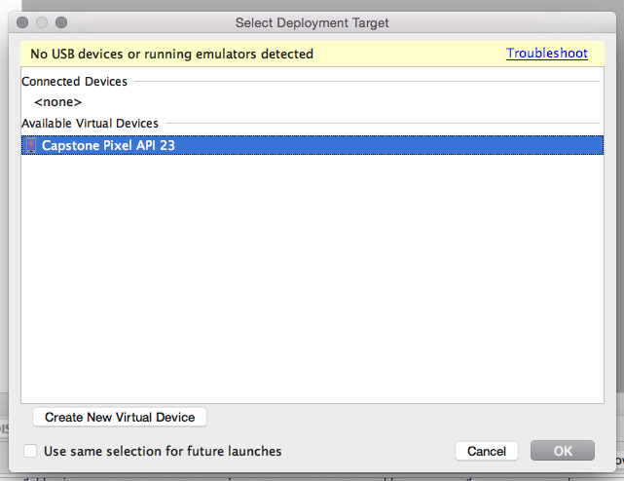

Be patient, the emulator may take a few minutes to load.

If the app launches and doesn’t crash -- great! You are done **Step 1**. You can move onto **Step 2**.

If it does crash -- don’t worry. A message will appear to inform you that the app has crashed. Click **OK**. Then, click the button near the bottom of the screen that is made up of six circles.



Click and drag to scroll through the apps until you find the **Settings** app. Click **Settings**.



Then click **Apps**.

This displays all apps on the emulator. Click and drag to scroll through the list. Near the bottom of the list you will find **SharingApp**. Click **SharingApp**.



After clicking **Sharing App**, click **Storage**. Then click **CLEAR DATA**. A message will pop up asking you to confirm this action. Click **OK**. Now all the previously stored data has been erased. At this point you may minimize the emulator.

**2. Create and implement the abstract Command class**

All concrete Command classes (**AddItemCommand**, **DeleteItemCommand**, **EditItemCommand**, **AddContactCommand**, **DeleteContactCommand**, and **EditContactCommand**) will inherit from an abstract **Command** class. We need to add this class to the project.

Create a new abstract class by right-clicking on the **com.example.sharingapp** folder, then click **New** → **Java Class**.

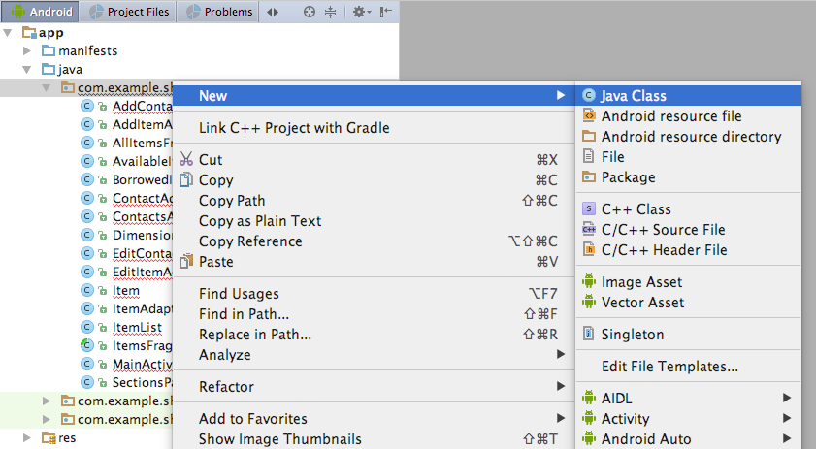

Name the class **Command**. Select the **Modifiers** option **Abstract**, then click **OK**.

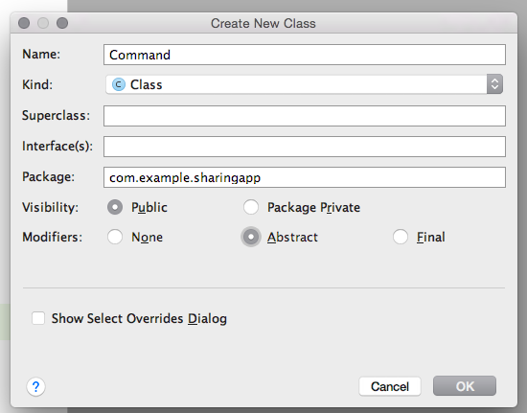

This creates an empty abstract **Command** class.

Replace the contents of the **Command** class with:

**package** com.example.sharingapp;

*/\*\**

*\* Superclass of AddContactCommand, EditContactCommand, DeleteContactCommand,*

*\* AddItemCommand, EditItemCommand, DeleteItemCommand*

*\*/*

**public abstract class** Command {

**private boolean is_executed**;

**public** Command(){

**is_executed** = **false**;

}

**public abstract void** execute();

**public boolean** isExecuted(){

**return is_executed**;

}

**public void** setIsExecuted(**boolean** is_executed) {

**this**.**is_executed** = is_executed;

}

}

**3. Create and implement the AddItemCommand class**

Create a new class by right-clicking on the **com.example.sharingapp** folder, then click **New** → **Java Class**



Name the class **AddItemCommand**. Click **OK**.

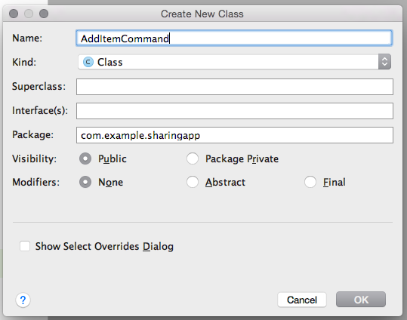

This creates an empty **AddItemCommand** class.

Replace the contents of the **AddItemCommand** class with:

**package** com.example.sharingapp;

**import** android.content.Context;

*/\*\**

*\* Command to add item*

*\*/*

**public class** AddItemCommand **extends** Command{

**private** ItemList **item_list**;

**private** Item **item**;

**private** Context **context**;

**public** AddItemCommand(ItemList item_list, Item item, Context context) {

**this**.**item_list** = item_list;

**this**.**item** = item;

**this**.**context** = context;

}

**public void** execute(){

**item_list**.addItem(**item**);

setIsExecuted(**item_list**.saveItems(**context**));

}

}

Notice that item_list.saveItems(context); is underlined in red.

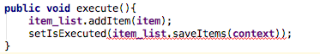

This is because the **ItemList** class does not have a method called **saveItems()** that matches that signature, i.e, **setIsExecuted()** is expecting that **item_list**.saveItems(**context**) will return a boolean, but instead it returns void.

Let’s take a look at **ItemList** to sort this out.

**4. Update the ItemList class**

Double click on the **ItemList** class to open it. Navigate to the **saveItems()** method. Replace the current **saveItems()** method with:

**public boolean** saveItems(Context context) {

**try** {

FileOutputStream fos = context.openFileOutput(**FILENAME**, 0);

OutputStreamWriter osw = **new** OutputStreamWriter(fos);

Gson gson = **new** Gson();

gson.toJson(*items*, osw);

osw.flush();

fos.close();

} **catch** (FileNotFoundException e) {

e.printStackTrace();

**return false**;

} **catch** (IOException e) {

e.printStackTrace();

**return false**;

}

**return true**;

}

**5. Create and implement the DeleteItemCommand class**

Create a new class by right-clicking on the **com.example.sharingapp** folder, then click **New** → **Java Class**.

Name the class **DeleteItemCommand**. Click **OK**. This creates an empty **DeleteItemCommand** class.

Replace the contents of **DeleteItemCommand** with:

**package** com.example.sharingapp;

**import** android.content.Context;

*/\*\**

*\* Command to delete an item*

*\*/*

**public class** DeleteItemCommand **extends** Command {

**private** ItemList **item_list**;

**private** Item **item**;

**private** Context **context**;

**public** DeleteItemCommand(ItemList item_list, Item item, Context context) {

**this**.**item_list** = item_list;

**this**.**item** = item;

**this**.**context** = context;

}

**public void** execute() {

**item_list**.deleteItem(**item**);

setIsExecuted(**item_list**.saveItems(**context**));

}

}

**6. Create and implement the EditItemCommand class**

Create a new class by right-clicking on the **com.example.sharingapp** folder, then click **New** → **Java Clas.s**

Name the class **EditItemCommand**. Click **OK**. This creates an empty **EditItemCommand** class.

Replace the contents of **EditItemCommand** with:

**package** com.example.sharingapp;

**import** android.content.Context;

*/\*\**

*\* Command to edit a pre-existing item*

*\*/*

**public class** EditItemCommand **extends** Command {

**private** ItemList **item_list**;

**private** Item **old_item**;

**private** Item **new_item**;

**private** Context **context**;

**public** EditItemCommand(ItemList item_list, Item old_item, Item new_item, Context context) {

**this**.**item_list** = item_list;

**this**.**old_item** = old_item;

**this**.**new_item** = new_item;

**this**.**context** = context;

}

**public void** execute() {

**item_list**.deleteItem(**old_item**);

**item_list**.addItem(**new_item**);

setIsExecuted(**item_list**.saveItems(**context**));

}

}

Now that we have created all the Commands related to the **ItemList** class (**AddItemCommand**, **DeleteItemCommand**, and **EditItemCommand**) it is time to update our Activities to use these Commands instead of directly interacting with the **ItemList** model.

**7. Update AddItemActivity to use AddItemCommand**

Double click on **AddItemActivity** to edit it.

Locate the **saveItem()** method. Locate the following lines within the **saveItem()** method:

**item_list**.addItem(item);

**item_list**.saveItems(**context**);

Replace these (above) two lines with:

*// Add item*

AddItemCommand add_item_command = **new** AddItemCommand(**item_list**, item, **context**);

add_item_command.execute();

**boolean** success = add_item_command.isExecuted();

**if** (!success){

**return**;

}

**8. Update EditItemActivity to use DeleteItemCommand and EditItemCommand**

Double click on **EditItemActivity** to edit it.

Locate the **saveItem()** method. Locate the following lines within the **saveItem()** method:

**item_list**.deleteItem(**item**);

**item_list**.addItem(item);

**item_list**.saveItems(**context**);

Replace these (above) three lines with:

*// Edit item*

EditItemCommand edit_item_command = **new** EditItemCommand(**item_list**, **item**, updated_item, **context**);

edit_item_command.execute();

**boolean** success = edit_item_command.isExecuted();

**if** (!success){

**return**;

}

Locate the **deleteItem()** method. Locate the following lines within the **deleteItem()** method:

**item_list**.deleteItem(**item**);

**item_list**.saveItems(**context**);

Replace these (above) two lines with:

*// Delete item*

DeleteItemCommand delete_item_command = **new** DeleteItemCommand(**item_list**, **item**, **context**);

delete_item_command.execute();

**boolean** success = delete_item_command.isExecuted();

**if** (!success){

**return**;

}

Now that we have implemented all the **ItemList** related commands, it is your turn to implement the **ContactList** related commands: **AddContactCommand**, **DeleteContactCommand**, and **EditContactCommand**. You will find that these commands are essentially analogous to **AddItemCommand**, **DeleteItemCommand**, and **EditItemCommand**, respectfully. Additionally ,the process involved in updating the application to accommodate these new commands is also completely analogous.

**9. Create and implement the AddContactCommand class**

Create a new class by right-clicking on the **com.example.sharingapp** folder, then click **New** → **Java Class**.

Name the class **AddContactCommand**. Click **OK**. This creates an empty **AddContactCommand** class.

Implement the **AddContactCommand** class. **Hint**: this step is analogous to **Step 3**.

**10. Update the ContactList class**

Double click on the **ContactList** class to open it. Navigate to the **saveContacts()** method.

Update the current **saveContacts()** method. **Hint**: this step is analogous to **Step 4**.

**11. Create and implement the DeleteContactCommand class**

Create a new class by right-clicking on the **com.example.sharingapp** folder, then click **New** → **Java Class**.

Name the class **DeleteContactCommand**. Click **OK**. This creates an empty **DeleteContactCommand** class.

Implement the **DeleteContactCommand** class. **Hint**: this step is analogous to **Step 5**.

**12. Create and implement the EditContactCommand class**

Create a new class by right-clicking on the **com.example.sharingapp** folder, then click **New** → **Java Class**.

Name the class **EditContactCommand**. Click **OK**. This creates an empty **EditContactCommand** class.

Implement the **EditContactCommand** class. **Hint**: this step is analogous to **Step 6**.

Now that we have created all the Commands related to the **ContactList** class (**AddContactCommand**, **DeleteContactCommand**, and **EditContactCommand**) it is time to update our Activities to use these Commands instead of directly interacting with the **ContactList** model.

**13. Update AddContactActivity to use AddContactCommand**

Double click on **AddContactActivity** to edit it. Locate the **saveContact()** method.

Update the **saveContact()** method. **Hint**: this step is analogous to **Step 7**.

**14. Update EditContactActivity to use DeleteContactCommand and EditContactCommand**

Double click on **EditContactActivity** to edit it.

Locate the **saveContact()** and method. Update the **saveContact()** method.

Locate the **deleteContact()** and method. Update the **deleteContact()** method.

**Hint**: this step is analogous to **Step 8**.

**15. Run the app**

Assuming you have correctly implemented the Command Design Pattern then at this point you should be able to run the app by clicking the **play** button.



If the emulator is not already launched you will be prompted to select it, then press **OK**.

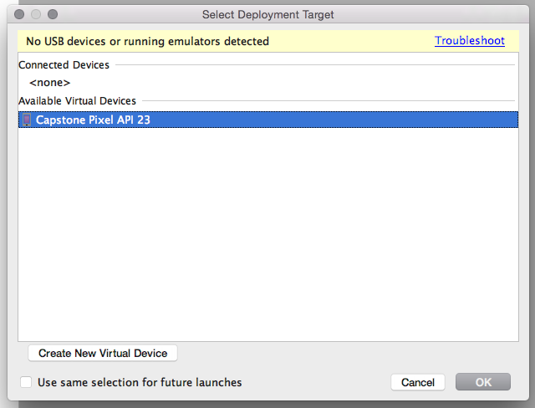

Be patient! It make take a few minutes to open and launch SharingApp.